Computer Mouse – Internal Circuit Description

Introduction
A computer mouse is an input device used to control the movement of the cursor on a computer screen. The image shows the internal printed circuit board (PCB) of an optical USB mouse. This circuit controls movement detection, button clicks, and communication with the computer.

Main Components Identified in the Picture
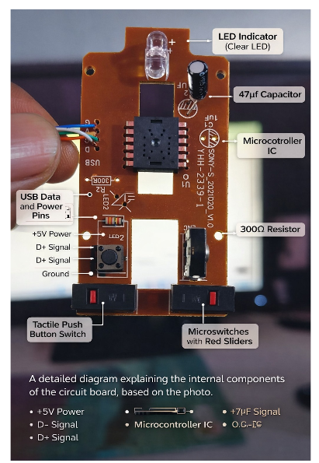

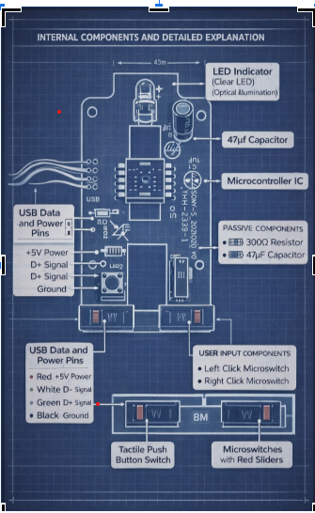

1. Optical Sensor (Center IC)
- Located at the center of the PCB.
- Detects movement by tracking changes on the surface below the mouse.
- Works together with the LED light source.
- Converts motion into digital signals.

2. LED (Light Emitting Diode)
- Positioned near the optical sensor.
- Illuminates the surface beneath the mouse.
- Helps the sensor accurately detect movement.
- Marked with polarity (+) on the PCB.

3. Microcontroller / Controller IC
- Processes signals from the optical sensor.
- Converts movement and button clicks into data.
- Sends data to the computer through the USB cable.

4. Left and Right Click Switches
- Mechanical switches located at the bottom left and right.
- Register left-click and right-click actions.
- Each press completes a circuit.

5. Middle Button (Scroll Button)
- Used for scrolling and middle-click actions.
- Located between the left and right buttons.

6. USB Cable Connections
- Wires visible on the side of the PCB.
- Typical colors:
  - Red: Power (+5V)
  - Black: Ground
  - Green: Data+
  - White: Data–
- Connects the mouse to the computer.

7. Resistors and Capacitors
- Control current flow and voltage stability.
- Ensure smooth and reliable operation of the mouse.

Working Principle
- The LED lights up the surface below the mouse.
- The optical sensor captures surface movement.
- The controller processes the movement data.
- Button presses are detected by switches.
- Data is sent to the computer via USB.
- The cursor moves and clicks are registered on the screen.

┌──────────┐

│ START │

└──────────┘

↓

┌──────────────────┐

│ USB Power Supply │

│ (5V from PC) │

└──────────────────┘

↓

┌──────────────────┐

│ LED Emits Light │

│ (Illuminates │

│ surface) │

└──────────────────┘

↓

┌──────────────────┐

│ Optical Sensor │

│ Detects movement │

└──────────────────┘

↓

┌──────────────────┐

│ Microcontroller │

│ Processes data │

└──────────────────┘

↓

┌──────────────────────────┐

│ Button / Scroll Input ? │

└──────────────────────────┘

↓

┌──────────────────┐

│ Data sent to PC │

│ via USB cable │

└──────────────────┘

↓

┌──────────────────┐

│ Cursor Movement │

│ on Screen │

└──────────────────┘

↓

